**#Python program to show the concept of filters**

def find_odd(x):

if x%2==1:

return True

else:

return False

nums=[11,22,33,44,55]

result=list(filter(find_odd,nums))

print(nums)

print('odd:',result)

print('-'*20)

num=[11,22,33,44,55]

result=list(filter(lambda x:x%2==1,num))

print('odd:',result)

print('-'*20)

result=list(filter(lambda x:x%2==0,num))

print('even',result)

**OUTPUT**

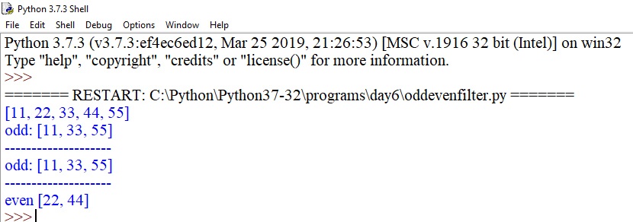

x=['python','java',88,99,33.7,11,'c++','pearl','ada']

def fun_str(a):

if isinstance(a,str):

return a

y=list(filter(fun_str,x))

z=list(filter(lambda a:isinstance(a,int),x))

p=list(filter(lambda a:isinstance(a,(int,float)),x))

print(y)

print(z)

print(p)

**OUTPUT**

